Задание выполнялось на компьютере со следующими параметрами:

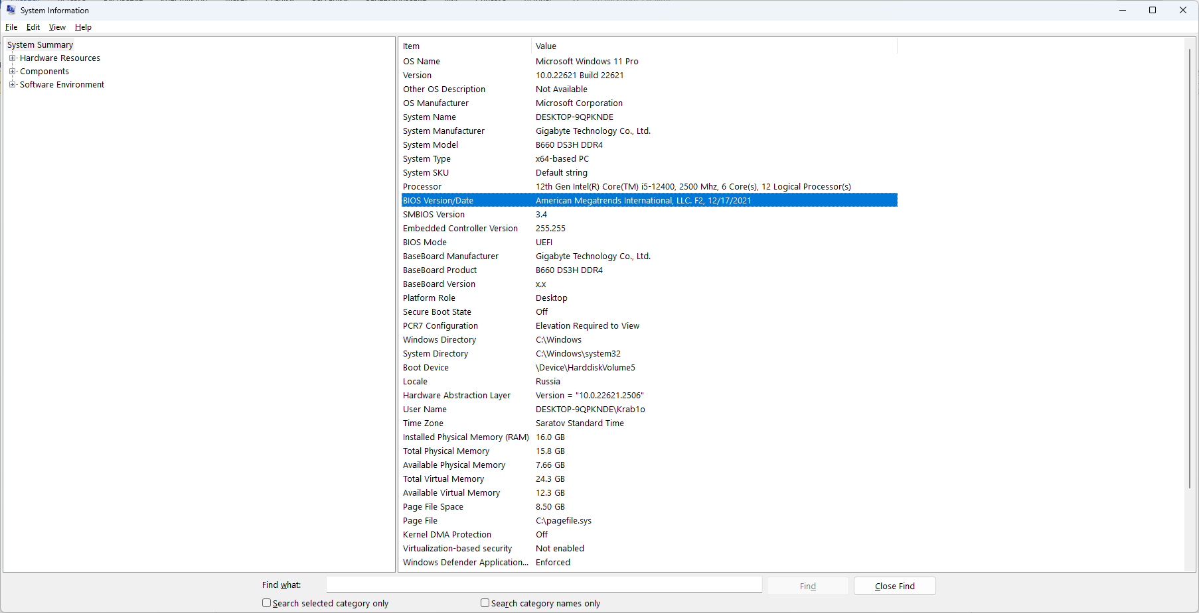

Из важного:

CPU: 12th Gen Intel(R) Core(TM) i5-12400, 2500 Mhz, 6 Core(s), 12 Logical Processor(s)

Motherboard: B660 DS3H DDR4

RAM: 16.0 GB со скоростью 2400MHz

Вариант 4. Решить следующую СЛАУ:

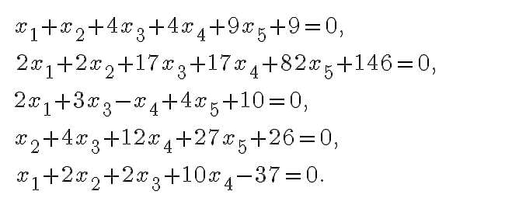

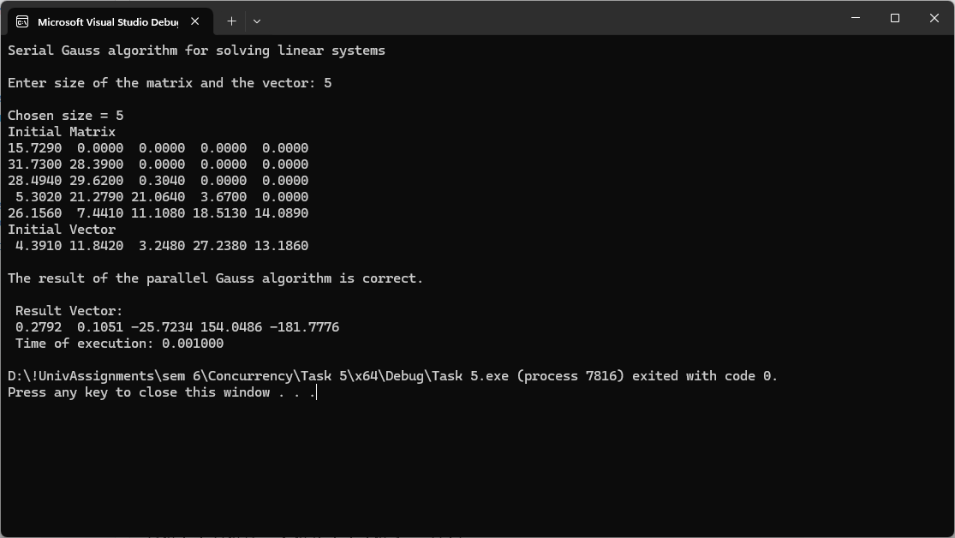СЛАУ была приведена к ступенчатому виду, решена, затем проверка подтвердила, что результат работы параллельного алгоритма Гаусса верный.

#define _CRT_SECURE_NO_WARNINGS

// SerialGauss.cpp

#include <stdio.h>

#include <stdlib.h>

#include <conio.h>

#include <time.h>

#include <math.h>

#include <omp.h>

typedef struct {

int PivotRow;

double MaxValue;

} TThreadPivotRow;

int* pPivotPos; // The number of pivot rows selected at the iterations

int* pPivotIter; // The iterations, at which the rows were pivots

// Function for simple initialization of the matrix

// and the vector elements

void DummyDataInitialization(double* pMatrix, double* pVector, int

Size) {

int i, j; // Loop variables

for (i = 0; i < Size; i++) {

pVector[i] = i + 1;

for (j = 0; j < Size; j++) {

if (j <= i)

pMatrix[i * Size + j] = 1;

else

pMatrix[i * Size + j] = 0;

}

}

}

// Function for random initialization of the matrix

// and the vector elements

void RandomDataInitialization(double* pMatrix, double* pVector,

int Size) {

int i, j; // Loop variables

srand(unsigned(clock()));

for (i = 0; i < Size; i++) {

pVector[i] = rand() / double(1000);

for (j = 0; j < Size; j++) {

if (j <= i)

pMatrix[i * Size + j] = rand() / double(1000);

else

pMatrix[i * Size + j] = 0;

}

}

}

void TaskInitialization(double* pMatrix, double* pVector, int Size)

{

//constant terms

pVector[0] = -9;

pVector[1] = -146;

pVector[2] = -10;

pVector[3] = -26;

pVector[4] = 37;

//row 1

pMatrix[0] = 1;

pMatrix[1] = 1;

pMatrix[2] = 4;

pMatrix[3] = 4;

pMatrix[4] = 9;

//row 2

pMatrix[5] = 2;

pMatrix[6] = 2;

pMatrix[7] = 17;

pMatrix[8] = 17;

pMatrix[9] = 82;

//row 3

pMatrix[10] = 2;

pMatrix[11] = 0;

pMatrix[12] = 3;

pMatrix[13] = -1;

pMatrix[14] = 4;

//row 4

pMatrix[15] = 0;

pMatrix[16] = 1;

pMatrix[17] = 4;

pMatrix[18] = 12;

pMatrix[19] = 27;

//row 5

pMatrix[20] = 1;

pMatrix[21] = 2;

pMatrix[22] = 2;

pMatrix[23] = 10;

pMatrix[24] = 0;

}

// Function for memory allocation and definition of the objects elements

void ProcessInitialization(double*& pMatrix, double*

& pVector,

double*& pResult, int& Size) {

// Setting the size of the matrix and the vector

do {

printf("\nEnter size of the matrix and the vector: ");

scanf("%d", &Size);

printf("\nChosen size = %d \n", Size);

if (Size <= 0)

printf("\nSize of objects must be greater than 0!\n");

} while (Size <= 0);

// Memory allocation

pMatrix = new double[Size * Size];

pVector = new double[Size];

pResult = new double[Size];

// Initialization of the matrix and the vector elements

RandomDataInitialization(pMatrix, pVector, Size);

//RandomDataInitialization(pMatrix, pVector, Size);

}

// Function for formatted matrix output

void PrintMatrix(double* pMatrix, int RowCount, int ColCount) {

int i, j; // Loop variables

for (i = 0; i < RowCount; i++) {

for (j = 0; j < ColCount; j++)

printf("%7.4f ", pMatrix[i * RowCount + j]);

printf("\n");

}

}

// Function for formatted vector output

void PrintVector(double* pVector, int Size) {

int i;

for (i = 0; i < Size; i++)

printf("%7.4f ", pVector[i]);

}

// Finding the pivot row

int ParallelFindPivotRow(double* pMatrix, int Size, int Iter) {

int PivotRow = -1; // The index of the pivot row

int MaxValue = 0; // The value of the pivot element

int i; // Loop variable

// Choose the row, that stores the maximum element

#pragma omp parallel

{

TThreadPivotRow ThreadPivotRow;

ThreadPivotRow.MaxValue = 0;

ThreadPivotRow.PivotRow = -1;

#pragma omp for

for (i = 0; i < Size; i++) {

if ((pPivotIter[i] == -1) &&

(fabs(pMatrix[i * Size + Iter]) > ThreadPivotRow.MaxValue)) {

ThreadPivotRow.PivotRow = i;

ThreadPivotRow.MaxValue = fabs(pMatrix[i * Size + Iter]);

}

}

//printf("\n Local thread (id = %i) pivot row: %i", omp_get_thread_num(), ThreadPivotRow.PivotRow);

#pragma omp critical

{

if (ThreadPivotRow.MaxValue > MaxValue) {

MaxValue = ThreadPivotRow.MaxValue;

PivotRow = ThreadPivotRow.PivotRow;

}

}

}

return PivotRow;

}

void ParallelColumnElimination(double* pMatrix, double* pVector,

int Pivot, int Iter, int Size) {

double PivotValue, PivotFactor;

PivotValue = pMatrix[Pivot * Size + Iter];

#pragma omp parallel for private(PivotFactor) schedule(dynamic,1)

for (int i = 0; i < Size; i++) {

if (pPivotIter[i] == -1) {

PivotFactor = pMatrix[i * Size + Iter] / PivotValue;

for (int j = Iter; j < Size; j++) {

pMatrix[i * Size + j] -= PivotFactor * pMatrix[Pivot * Size + j];

}

pVector[i] -= PivotFactor * pVector[Pivot];

}

}

}

void ParallelBackSubstitution(double* pMatrix, double* pVector,

double* pResult, int Size) {

int RowIndex, Row;

for (int i = Size - 1; i >= 0; i--) {

RowIndex = pPivotPos[i];

pResult[i] = pVector[RowIndex] / pMatrix[Size * RowIndex + i];

#pragma omp parallel for private (Row)

for (int j = 0; j < i; j++) {

Row = pPivotPos[j];

pVector[Row] -= pMatrix[Row * Size + i] * pResult[i];

pMatrix[Row * Size + i] = 0;

}

}

}

// Gaussian elimination

void ParallelGaussianElimination(double* pMatrix, double* pVector,

int Size) {

int Iter; // The number of the iteration of the Gaussian

// elimination

int PivotRow; // The number of the current pivot row

for (Iter = 0; Iter < Size; Iter++) {

// Finding the pivot row

PivotRow = ParallelFindPivotRow(pMatrix, Size, Iter);

pPivotPos[Iter] = PivotRow;

pPivotIter[PivotRow] = Iter;

ParallelColumnElimination(pMatrix, pVector, PivotRow, Iter, Size);

}

}

// Function for the execution of Gauss algorithm

void ParallelResultCalculation(double* pMatrix, double* pVector,

double* pResult, int Size) {

// Memory allocation

pPivotPos = new int[Size];

pPivotIter = new int[Size];

for (int i = 0; i < Size; i++) {

pPivotIter[i] = -1;

}

ParallelGaussianElimination(pMatrix, pVector, Size);

ParallelBackSubstitution(pMatrix, pVector, pResult, Size);

// Memory deallocation

delete[] pPivotPos;

delete[] pPivotIter;

}

// Function for computational process termination

void ProcessTermination(double* pMatrix, double* pVector, double*

pResult) {

delete[] pMatrix;

delete[] pVector;

delete[] pResult;

}

// Function for testing the result

void TestResult(double* pMatrix, double* pVector,

double* pResult, int Size) {

/* Buffer for storing the vector, that is a result of multiplication

of the linear system matrix by the vector of unknowns */

double* pRightPartVector;

// Flag, that shows wheather the right parts

// vectors are identical or not

int equal = 0;

double Accuracy = 1.e-6; // Comparison accuracy

pRightPartVector = new double[Size];

for (int i = 0; i < Size; i++) {

pRightPartVector[i] = 0;

for (int j = 0; j < Size; j++) {

pRightPartVector[i] +=

pMatrix[i * Size + j] * pResult[j];

}

}

for (int i = 0; i < Size; i++) {

if (fabs(pRightPartVector[i] - pVector[i]) > Accuracy)

equal = 1;

}

if (equal == 1)

printf("\n\nThe result of the parallel Gauss algorithm is NOT correct."

"Check your code.\n");

else

printf("\n\nThe result of the parallel Gauss algorithm is correct.\n");

delete[] pRightPartVector;

}

int main() {

double* pMatrix; // The matrix of the linear system

double* pVector; // The right parts of the linear system

double* pResult; // The result vector

int Size; // The sizes of the initial matrix and the vector

double start, finish, duration;

printf("Serial Gauss algorithm for solving linear systems\n");

// Memory allocation and definition of objects' elements

ProcessInitialization(pMatrix, pVector, pResult, Size);

// The matrix and the vector output

printf("Initial Matrix \n");

PrintMatrix(pMatrix, Size, Size);

printf("Initial Vector \n");

PrintVector(pVector, Size);

// Execution of Gauss algorithm

start = clock();

ParallelResultCalculation(pMatrix, pVector, pResult, Size);

finish = clock();

duration = (finish - start) / CLOCKS_PER_SEC;

TestResult(pMatrix, pVector, pResult, Size);

// Printing the result vector

printf("\n Result Vector: \n");

PrintVector(pResult, Size);

// Printing the execution time of Gauss method

printf("\n Time of execution: %f\n", duration);

// Computational process termination

ProcessTermination(pMatrix, pVector, pResult);

return 0;

}